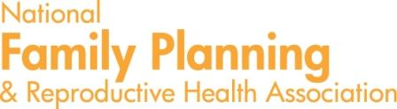

March 28, 2017

NAME
ORGANIZATION
ADDRESS

Dear NAME:

On behalf of the National Family Planning & Reproductive Health Association (NFPRHA), I am urging the attendance of NAME at our May 10-11, 2017 Title X Grantee Meeting in St. Louis, Missouri. The meeting, which has been especially designed for grantees of Title X funding, will provide opportunities for executives, administrators, and clinicians to discuss policy issues, strategies, and action steps.

The Title X grantee meeting will cover essential information designed to help the Title X network plan for and mitigate the consequences of federal health policy changes. Title X funds may be substantially reduced or the program could be eliminated outright in upcoming appropriations bills. The meeting will also focus on other policy and service delivery areas, including reduced health care coverage that may impact providers’ sustainability and Medicaid, which is the primary payer of publicly funded family planning care and has important family planning requirements in statute, regulation, and guidance.

FIRST NAME’s participation at this national meeting is essential given the focus on scenario planning and contingency development. His/Her participation will benefit and strengthen the [Commonwealth/Department’]s goals of ensuring the provision of high-quality family planning services in accordance with the Title X program requirements.

FIRST NAME’s Title X expertise is greatly needed and appreciated on a national level. NFPRHA will provide FIRST NAME with all expenses for this meeting, including covering his/her airfare and 2 nights of hotel stay, except meals on travel days. We hope that s/he can attend this important meeting. Thank you again for your support of his/her work. If you have any questions about the meeting or FIRST NAME’s role in it, please contact me at ccoleman@nfprha.org or 202-293-3114.

Sincerely,

Clare Coleman
President & CEO

